Bicycles as part of a sustainable transport system
By Carlos F. Pardo, Project Coordinator, Sustainable Urban Transport Project
In transport, many modes have been defined as “the most appropriate” or “the most efficient”. After many years of debate, academics and practitioners of sustainable urban transport have found that there is not a “most” sustainable, appropriate or efficient mode of transport, the truth is that what should be sustainable is the transport system, where various modes play a key role. Predominantly, public transport, walking and bicycles are the most favourable components of such a system. This brief article will discuss why bicycles are one of these modes.
Bicycles (or an initial design of a very similar vehicle) have been around since the middle of the nineteenth century, and were actually introduced as recreational vehicles for high-class citizens. During the second half of that century they were exclusively being used by the high-income population in Europe and some other places in the world (also as a mode of transport). However, when the automobile was introduced the bicycle was
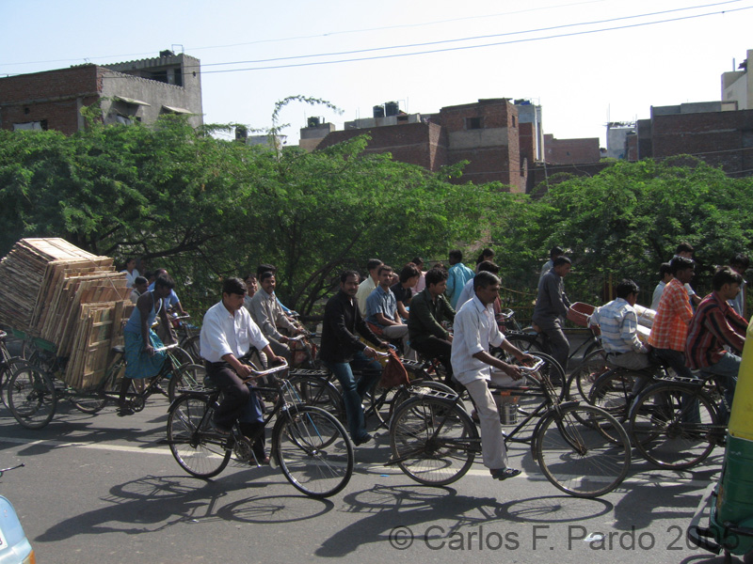
Bicycles as an important means of travel in New Delhi (Source: GTZ Photo DVD)
transformed into both a vehicle for the middle and low- income and a recreational and sports vehicle for children and the general population.
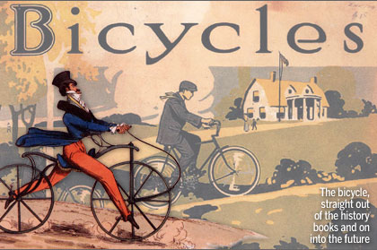
DRAISINE BICYCLE – Oldest known bicycle (Source: http://www.pedalpushersonline.com/?CID=785)
It was during the oil crisis of the 1970s that the bicycle became again a preferred transport mode in Europe, as was starting also to be the case in China and other places in the world. However, other countries kept promoting the use of the automobile, as it was part of a “modern” conception of cities, which implied high speeds, long distances and sprawl. However, the bicycle was starting to be a mode of transport that would work as an antidote to these supposedly “good” qualities of cities. Urbanists, sociologists and others were starting to find the consequences of excessive use of energy in transport, high speeds along highways and dependency on automobiles as the only mode of transport.
In light of this situation, GTZ SUTP, along with other sustainable transport initiatives such as I-ce (Interface for Cycling Expertise- www.ice.info ) and the ITDP (Institute for Transport & Development Policy – www.itdp.org )have strongly promoted the inclusion of bicycling as part of a coherent transport policy. GTZ has developed a module on non motorised transport and a training document on the same topic which covers some of the concepts which can make this possible. Before the end of 2007, GTZ and I-ce will publish a new training document focussing on cycling as part of a sustainable transport agenda. Registered users can download the mentioned modules free of charge. To register click here.
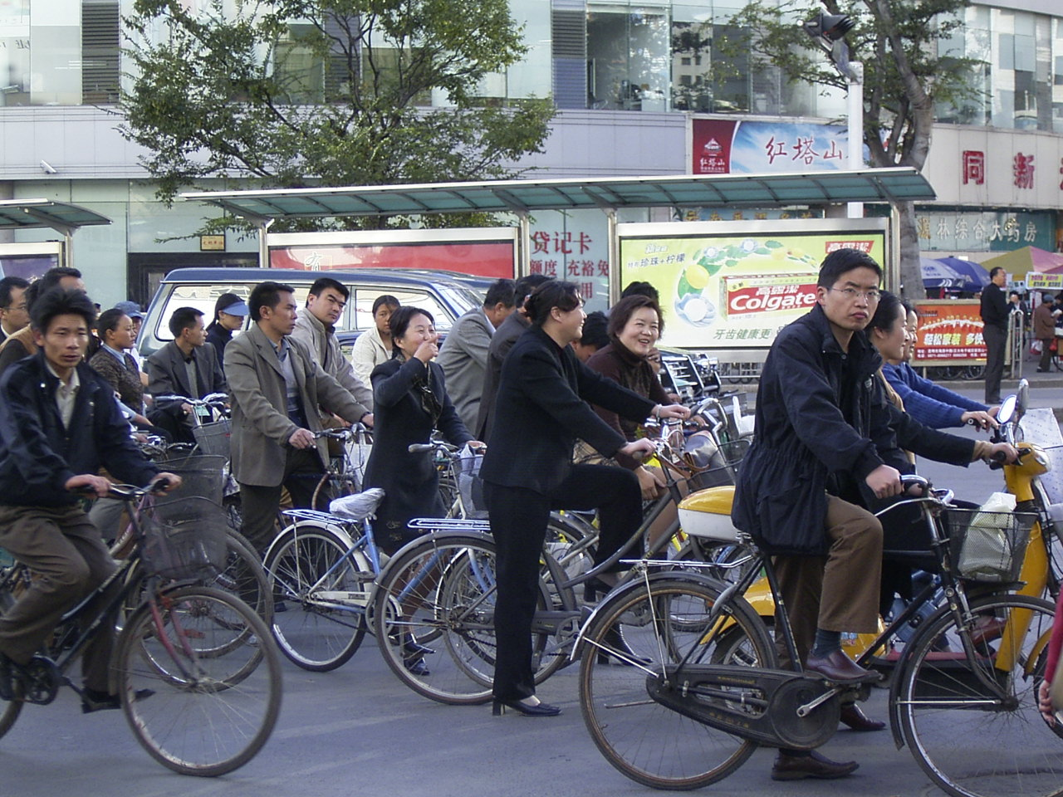
Bicycles in Beijing (Source: GTZ Photo DVD)

